
Information Flow Diagram
HOT Architecture Documentation

This document provides an overview of an information flow diagram, then digs into the mechanics of creating one in LibreOffice. For a general overview of the technical documentation approach for HOT, check out the technical documentation Wiki at https://github.com/hotosm/techdoc/wiki.
When it comes to solution architecture, an information flow diagram is a simple design view to depict the data movement aspect of any architecture. The goal of an information flow is to provide an approach for understanding a solution architecture. An information flow is often modeled using a block diagram (“boxes and lines”).
Table of Contents
Information Flow Diagram HOT Architecture Documentation 1
What is an information flow model? 1
Boxes and Lines 2
Elements of the diagram! 2
Some Tips 3
Drawing with LibreOffice 3
Getting Started 3
Page Setup 4
Connecting Components 4
Clean Up 5

What is an information flow model?
From our friends at Wikipedia:
The main purpose of an information flow diagram (IFD) is so that sources that send and receive information can be displayed neatly and analyzed. This allows viewers to see the forwarding of information and the analysis of different situations. The creation of an IFD is, in most cases, the first step in information analysis. IFDs are used to:

- Develop a high level overview of the flow of information in an organization.
- Highlight detailed flows in an individual task.
- Describe the flow of information inside and around organizations and between departments.
- Understand business process bottlenecks in sequential, deferred, real-time, parallel, wheel, one-to-many, many-to-many and many-to-one-to-many information flows.
We use Information Flows to capture the components within an architecture where data is at rest (stored) and the flows of information between those components.

Boxes and Lines
Given the high level of abstraction for an information flow diagram, we model it using “boxes and lines”. Each block is labeled with the name of a component and the flow of information is depicted with a line. If information only flows in one direction, the line can have an arrow. These lines are labeled with the specific information flowing. If information flows in both directions, add arrowheads to the labels instead.
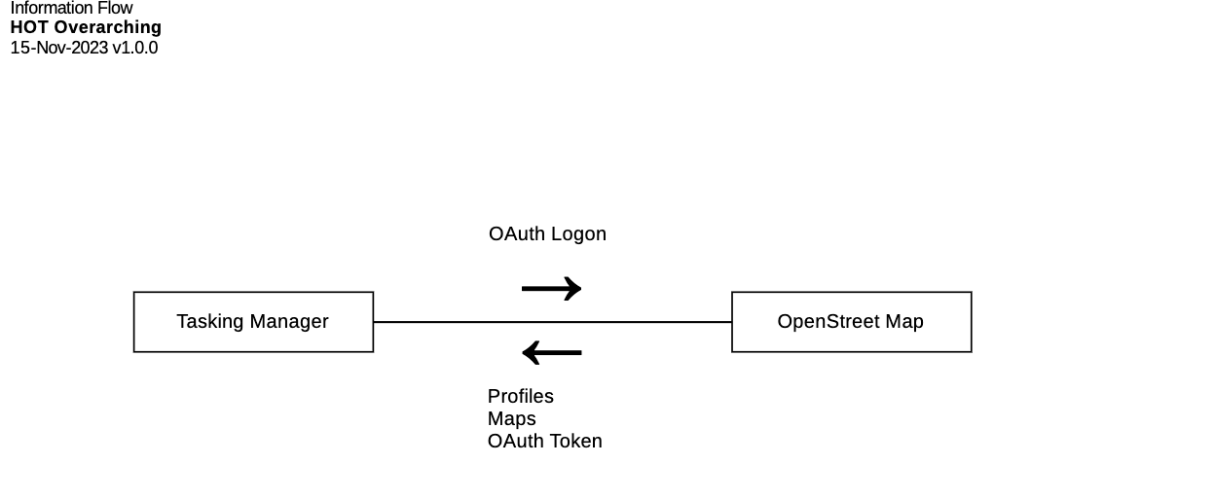

Elements of the diagram!
Here is a quick review of how to think about each element on the diagram:
- Each rectangular box is called a component. For our purposes, a component is any place in the architecture where information “rests”.
- Each line with an arrow indicates the direction of information flow between components.
- A label on the line provides a high-level description of the information that is flowing. If information flows in both directions between the components, use arrow heads in each label (instead of on the line) to indicate the direction.
- Use the UML Note shape during drafting to capture open questions and when publishing to provide clarifications. Try to use sparingly on published diagrams.
- Use bounding boxes (with dotted borders), swimlanes, or page placement to add additional dimensions, group together components, or indicate Information Hubs (see “Some Tips”).
- Fonts, colors, and line styles can be used to add additional information, but be intentional. Too much “helpful information” can cause over complication and become more distracting than useful.

Some Tips
Before we get started on the mechanics, here are a few tips:
- Including information hubs can hide where the data is actually flowing. Try using one of these strategies to manage information hubs:
  - Leave them off! If an information hub is always used to move data, add it as a “global” note near the title of the diagram.
  - Use a labeled bounding box (with a dotted border) to indicate which components use the information hub.
  - Use a note attached to a component to identify the information hub used.
- Focus on the primary objective of the interaction instead of any back and forth “conversation” between compenents.
- Keep flow descriptions as high level as possible and use adjectives to make sure information labels are mutually exclusive.
- Keep all the boxes the same size. It makes your diagram look cleaner and more professional.
- Align boxes vertically and horizontally as much as feasible. It makes your diagram look cleaner and more professional.

Drawing with LibreOffice

Getting Started
This assumes you know how to use LibreOffice Draw and provides additional guidance to help you create this specific diagram in LibreOffice. Please checkout these resources to learn more about using LibreOffice:
- https://www.libreoffice.org/get-help/install-howto/
- https://documentation.libreoffice.org/
- https://documentation.libreoffice.org/assets/Uploads/Documentation/en/DG7.5/DG75-DrawGuide.pdf
- https://help.libreoffice.org/latest
It is also often quickest to grab an existing diagram and edit instead if starting from scratch. You can find an existing conceptual diagram here: https://github.com/hotosm/techdoc/blob/main/overarching-architecture/tasking-manager/Tasking%20Manager%20Information%20Flow.odg
Otherwise, start by using the file menu to Create a New Drawing.

Page Setup
If you are not using an existing diagram to start, make a copy of the Information Flow template and rename it to the name of your solution, e.g. “Tasking Manager Conceptual Diagram.odg.”
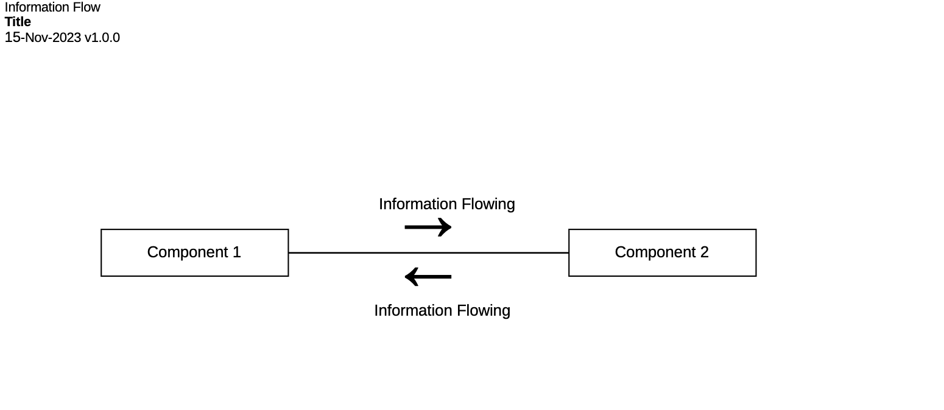
In the upper left, is our standard title block. Change the word “title” to the title of your diagram. It should describe the scope of your diagram. For example, “Tasking Manager.”
To use the template, simply make a copy of the component rectangles, rename, and position appropriately.

Connecting Components
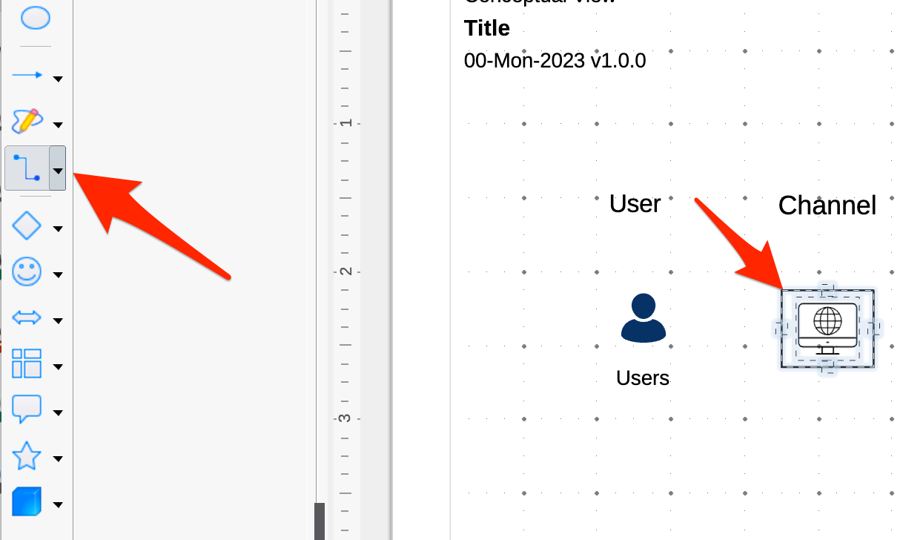
Once you have some components added to the diagram, you click the connector button on the shape bar on the left, then hover over any component. The connectors will appear on the component you are hovering over.
Click on any connector and holding the mouse button down, move the mouse over the other shape you would like to connect. Release the mouse button when it is hovering over one of the connectors on the other component.
You can use the toolbar at the top to fix the connection style:
- Change the line color to black and the style to dashed, and add arrows to one end depicting the flow of information between the two components. Alternatively, add no arrows to the line and depict the flow of information on the line label.
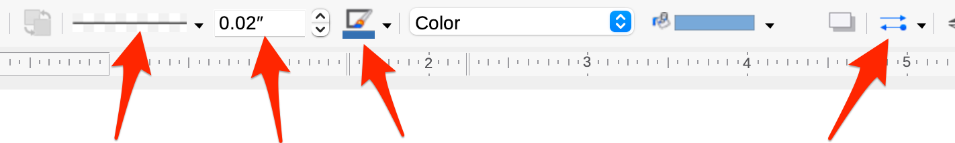
Line Style Line Thickness Line Color Line Arrows
Pro tip: If you select the right Line attributes with no connector selected, it will become your default for all future connectors.

Clean Up
Once you have your whole diagram laid out, select components and use the right-click “align” function to get them all in alignment accordingly.

The Carnegie Mellon University Software Engineering Institute refers to this kind of diagram as a Component and Connector view in their approach for documenting software architectures (“Views and Beyond”). https://resources.sei.cmu.edu/library/asset-view.cfm?assetID=484159
Scott Ambler’s book “Elements of UML Style 2.0” has some great general diagramming tips.

